This is the 2nd time I have tried the OAI Complete Setup
What had I done?
- This time I had doubts regarding what might the gNB be transmitting
so that is why I had gone back to USRP
in another SDR when tried to observe it will look like a noise bed , because the gNB will be transmitting the packets at a very high speed , that is why we will be seeing the noise like form
THE DISTANCE BETWEEN THE TWO SDR WAS 1.5 Meters
Then comes the establishing the communication between the gNB and the UE
- this was taking some time to detect the gNB , some times as soon as I on the gNB and then spontaneously on the UE it was detecting in seconds and sometimes it was not detecting at all.
Most of the time it was not detecting and will be showing synch issues like the pic I have pasted below
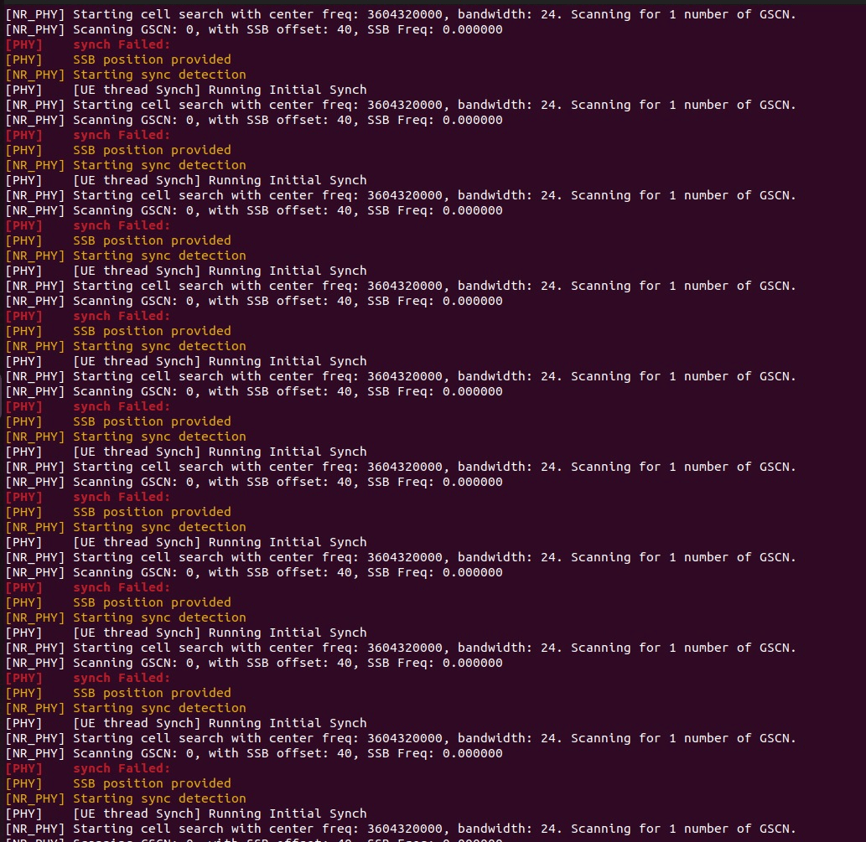

If you get like this steps to debug:-
1) Check if the gNB given command for UE is properly followed
2) Check the gain
3) Usually keep the setup ON and then move back for 5-10 mins , by that time it will establish the connection
4) If still then if not able to see the communication between the gNB and the UE , then check if the gNB is transmitting the PSS,SSS,PBCH

So here in the 2nd trial I tried the Setup with -gnb.sa.band78.fr1.24PRB.usrpb210.conf---
Active_gNBs = ( "gNB-OAI");
# Asn1_verbosity, choice in: none, info, annoying
Asn1_verbosity = "none";

gNBs =
(
{
////////// Identification parameters:
gNB_ID = 0xe00;
gNB_name = "gNB-OAI";

// Tracking area code, 0x0000 and 0xfffe are reserved values
tracking_area_code = 1;
plmn_list = ({ mcc = 001; mnc = 01; mnc_length = 2; snssaiList = ({ sst = 1 }) });

nr_cellid = 12345678L;

////////// Physical parameters:

sib1_tda = 15;
min_rxtxtime = 6;

servingCellConfigCommon = (
{
#spCellConfigCommon

physCellId = 0;

# downlinkConfigCommon
#frequencyInfoDL
# this is 3600 MHz + 12 PRBs@30kHz SCS (same as initial BWP)
absoluteFrequencySSB = 640320;
dl_frequencyBand = 78;
# this is 3600 MHz
dl_absoluteFrequencyPointA = 640000;
#scs-SpecificCarrierList
dl_offstToCarrier = 0;
# subcarrierSpacing
# 0=kHz15, 1=kHz30, 2=kHz60, 3=kHz120
dl_subcarrierSpacing = 1;
dl_carrierBandwidth = 24;
#initialDownlinkBWP
#genericParameters
# this is RBstart=27,L=48 (275*(L-1))+RBstart
initialDLBWPlocationAndBandwidth = 6325;
# subcarrierSpacing
# 0=kHz15, 1=kHz30, 2=kHz60, 3=kHz120
initialDLBWPsubcarrierSpacing = 1;
#pdcch-ConfigCommon
initialDLBWPcontrolResourceSetZero = 2;
initialDLBWPsearchSpaceZero = 0;

#uplinkConfigCommon
#frequencyInfoUL
ul_frequencyBand = 78;
#scs-SpecificCarrierList
ul_offstToCarrier = 0;
# subcarrierSpacing
# 0=kHz15, 1=kHz30, 2=kHz60, 3=kHz120
ul_subcarrierSpacing = 1;
ul_carrierBandwidth = 24;
pMax = 20;
#initialUplinkBWP
#genericParameters
initialULBWPlocationAndBandwidth = 6325;
# subcarrierSpacing
# 0=kHz15, 1=kHz30, 2=kHz60, 3=kHz120
initialULBWPsubcarrierSpacing = 1;
#rach-ConfigCommon
#rach-ConfigGeneric
prach_ConfigurationIndex = 98;
#prach_msg1_FDM
#0 = one, 1=two, 2=four, 3=eight
prach_msg1_FDM = 0;
prach_msg1_FrequencyStart = 0;
zeroCorrelationZoneConfig = 13;
preambleReceivedTargetPower = -96;
#preamblTransMax (0...10) = (3,4,5,6,7,8,10,20,50,100,200)
preambleTransMax = 6;
#powerRampingStep
# 0=dB0,1=dB2,2=dB4,3=dB6
powerRampingStep = 1;
#ssb_perRACH_OccasionAndCB_PreamblesPerSSB_PR
#1=oneeighth,2=onefourth,3=half,4=one,5=two,6=four,7=eight,8=sixteen
ssb_perRACH_OccasionAndCB_PreamblesPerSSB_PR = 4;
#one (0..15) 4,8,12,16,...60,64
ssb_perRACH_OccasionAndCB_PreamblesPerSSB = 14;
#ra_ContentionResolutionTimer
#(0..7) 8,16,24,32,40,48,56,64
ra_ContentionResolutionTimer = 7;
rsrp_ThresholdSSB = 19;
#prach-RootSequenceIndex_PR
#1 = 839, 2 = 139
prach_RootSequenceIndex_PR = 2;
prach_RootSequenceIndex = 1;
# SCS for msg1, can only be 15 for 30 kHz < 6 GHz, takes precendence over the one derived from prach-ConfigIndex
#
msg1_SubcarrierSpacing = 1,
# restrictedSetConfig
# 0=unrestricted, 1=restricted type A, 2=restricted type B
restrictedSetConfig = 0,

msg3_DeltaPreamble = 1;
p0_NominalWithGrant =-90;

# pucch-ConfigCommon setup :
# pucchGroupHopping
# 0 = neither, 1= group hopping, 2=sequence hopping
pucchGroupHopping = 0;
hoppingId = 40;
p0_nominal = -90;

ssb_PositionsInBurst_Bitmap = 1;

# ssb_periodicityServingCell
# 0 = ms5, 1=ms10, 2=ms20, 3=ms40, 4=ms80, 5=ms160, 6=spare2, 7=spare1
ssb_periodicityServingCell = 2;

# dmrs_TypeA_position
# 0 = pos2, 1 = pos3
dmrs_TypeA_Position = 0;

# subcarrierSpacing
# 0=kHz15, 1=kHz30, 2=kHz60, 3=kHz120
subcarrierSpacing = 1;

#tdd-UL-DL-ConfigurationCommon
# subcarrierSpacing
# 0=kHz15, 1=kHz30, 2=kHz60, 3=kHz120
referenceSubcarrierSpacing = 1;
# pattern1
# dl_UL_TransmissionPeriodicity
# 0=ms0p5, 1=ms0p625, 2=ms1, 3=ms1p25, 4=ms2, 5=ms2p5, 6=ms5, 7=ms10
dl_UL_TransmissionPeriodicity = 6;
nrofDownlinkSlots = 7;
nrofDownlinkSymbols = 6;
nrofUplinkSlots = 2;
nrofUplinkSymbols = 4;

ssPBCH_BlockPower = -25;
}

);

# ------- SCTP definitions
SCTP :
{
# Number of streams to use in input/output
SCTP_INSTREAMS = 2;
SCTP_OUTSTREAMS = 2;
};

////////// AMF parameters:
amf_ip_address = ({ ipv4 = "192.168.1.53"; });

NETWORK_INTERFACES :
{
GNB_IPV4_ADDRESS_FOR_NG_AMF = "192.168.1.43/24";
GNB_IPV4_ADDRESS_FOR_NGU = "192.168.1.43/24";
GNB_PORT_FOR_S1U = 2152; # Spec 2152
};

}
);

MACRLCs = (
{
num_cc = 1;
tr_s_preference = "local_L1";
tr_n_preference = "local_RRC";
pusch_TargetSNRx10 = 150;
pucch_TargetSNRx10 = 200;
}
);

L1s = (
{
num_cc = 1;
tr_n_preference = "local_mac";
pusch_proc_threads = 8;
prach_dtx_threshold = 120;
pucch0_dtx_threshold = 150;
ofdm_offset_divisor = 8; #set this to UINT_MAX for offset 0
}
);

RUs = (
{
local_rf = "yes"
nb_tx = 1
nb_rx = 1
att_tx = 0
att_rx = 0;
bands = [78];
max_pdschReferenceSignalPower = -27;
max_rxgain = 114;
sf_extension = 0;
eNB_instances = [0];
clock_src = "internal";
}
);

rfsimulator :
{
serveraddr = "server";
serverport = 4043;
options = (); #("saviq"); or/and "chanmod"
modelname = "AWGN";
IQfile = "/tmp/rfsimulator.iqs";
};

security = {
# preferred ciphering algorithms
# the first one of the list that an UE supports in chosen
# valid values: nea0, nea1, nea2, nea3
ciphering_algorithms = ( "nea0" );

# preferred integrity algorithms
# the first one of the list that an UE supports in chosen
# valid values: nia0, nia1, nia2, nia3
integrity_algorithms = ( "nia2", "nia0" );

# setting 'drb_ciphering' to "no" disables ciphering for DRBs, no matter
# what 'ciphering_algorithms' configures; same thing for 'drb_integrity'
drb_ciphering = "yes";
drb_integrity = "no";
};

log_config :
{
global_log_level ="info";
global_log_verbosity ="medium";
hw_log_level ="info";
hw_log_verbosity ="medium";
phy_log_level ="info";
phy_log_verbosity ="medium";
mac_log_level ="info";
mac_log_verbosity ="high";
rlc_log_level ="info";
rlc_log_verbosity ="medium";
pdcp_log_level ="info";
pdcp_log_verbosity ="medium";
rrc_log_level ="info";
rrc_log_verbosity ="medium";
ngap_log_level ="debug";
ngap_log_verbosity ="medium";
};

---------------------------------------------------------------------------------------------------------------------------------------------Then I ran the command in my gNB --
cd ~/openairinterface5g/cmake_targets/ran_build/build
sudo ./nr-softmodem -O ../../../targets/PROJECTS/GENERIC-NR-5GC/CONF/gnb.sa.band78.fr1.24PRB.usrpb210.conf
the gNB logs -----------
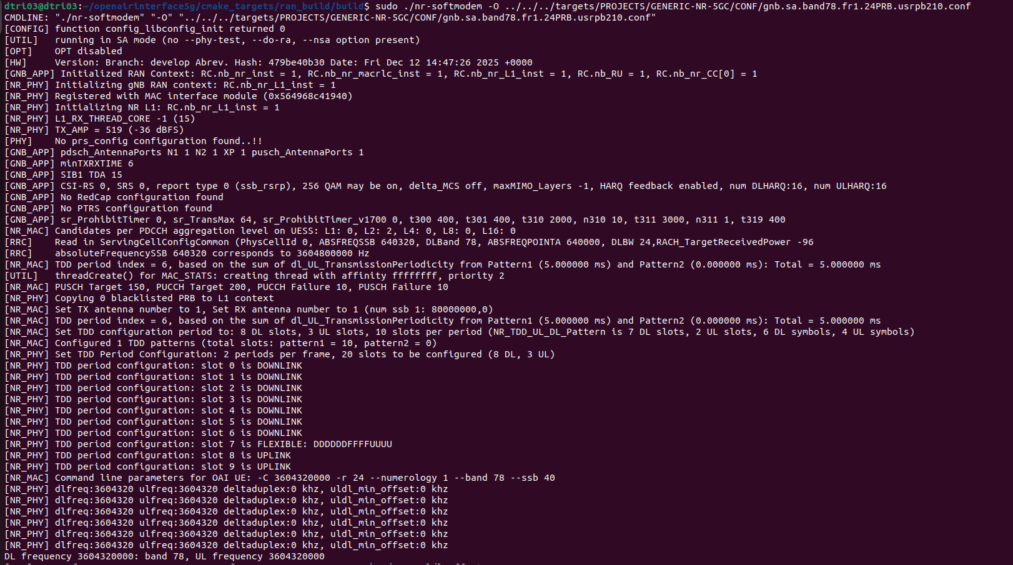
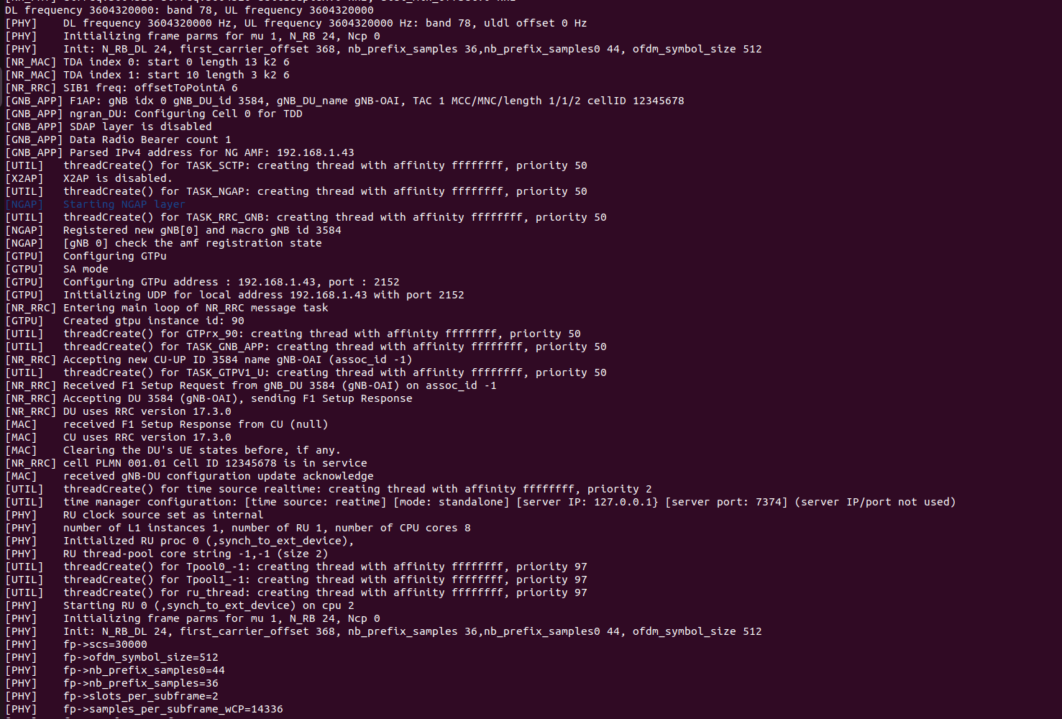
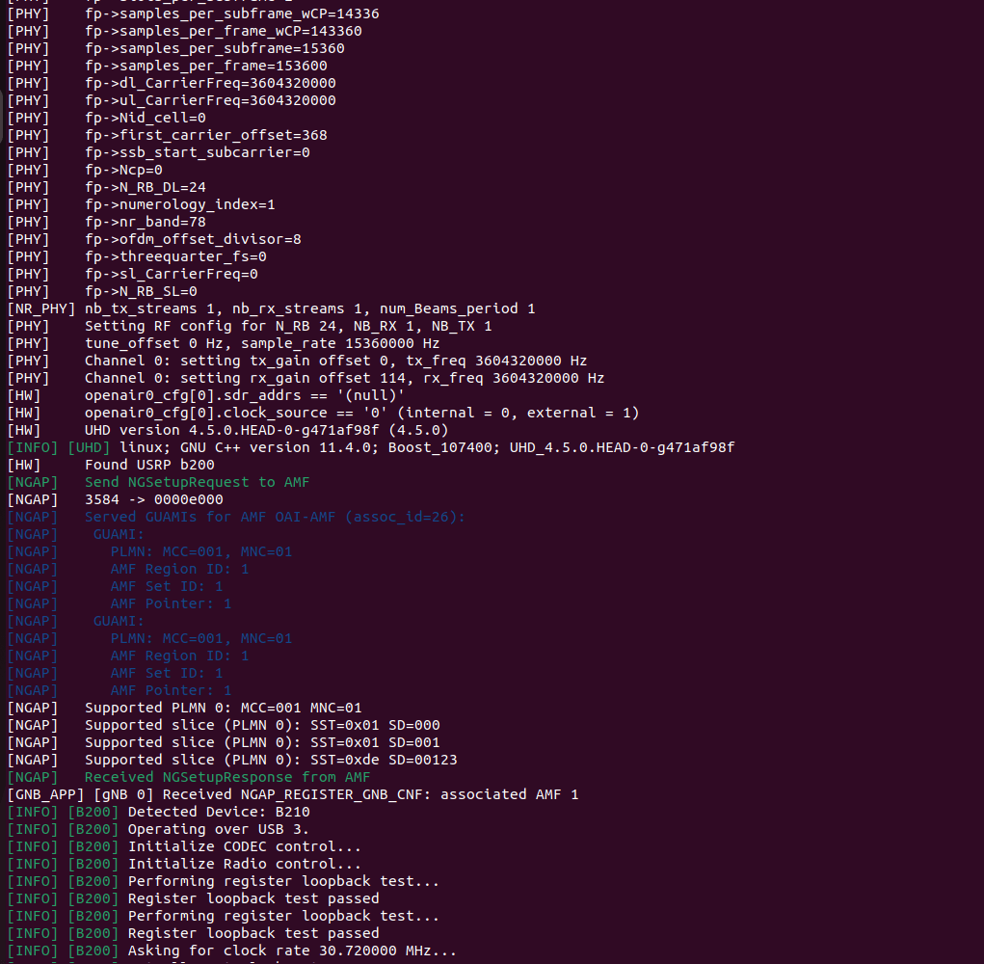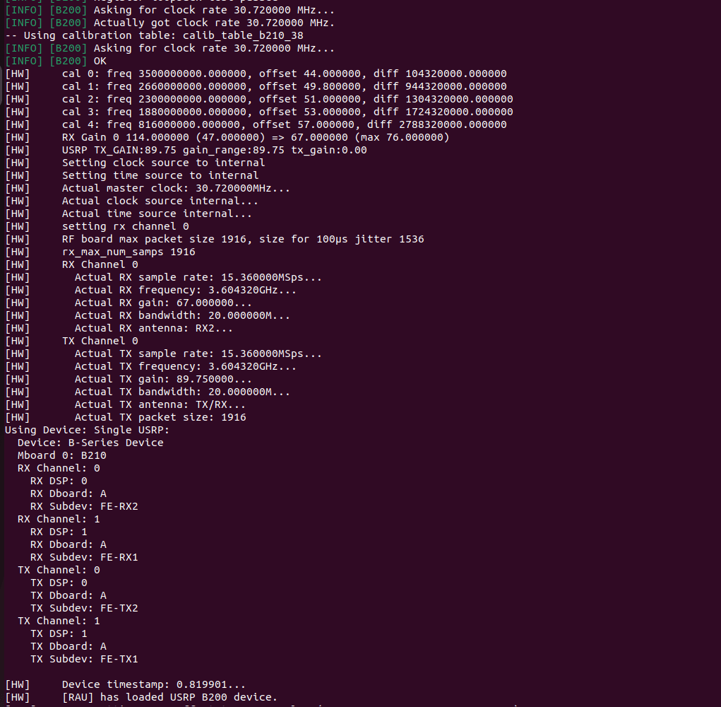
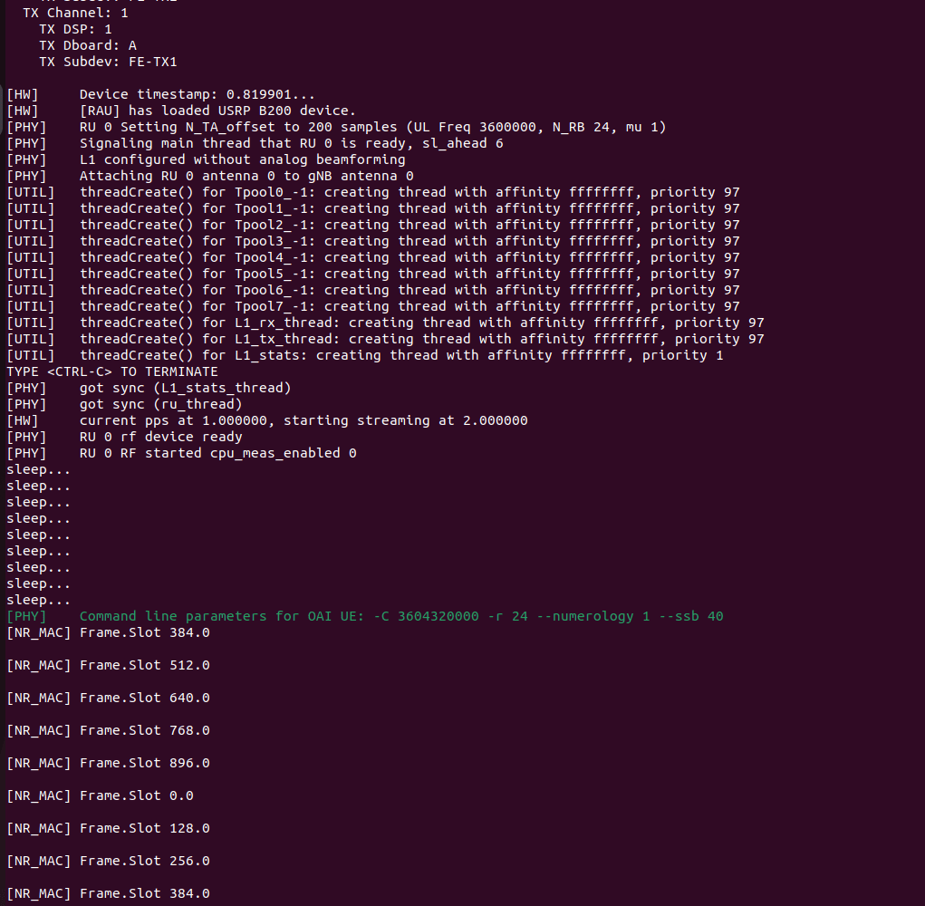
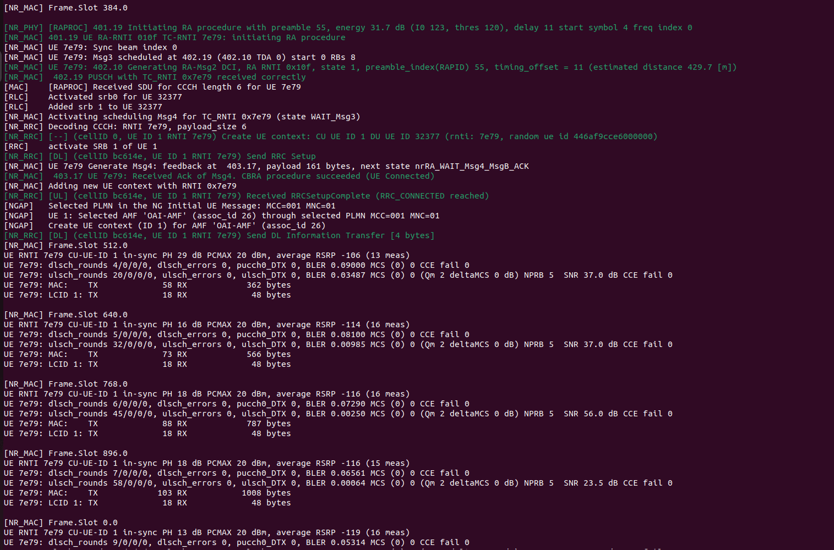
------------------------------------------------------------------------------------------------------------------------------------------------------------------------------------------------------------------------------------------------------------------------------------------The Below is the UE logs---------------
the below command when we run-
sudo ./nr-uesoftmodem -O ../../../targets/PROJECTS/GENERIC-NR-5GC/CONF/ue.conf -C 3604320000 -r 24 --numerology 1 --band 78 --ssb 40 --ue-fo-compensation
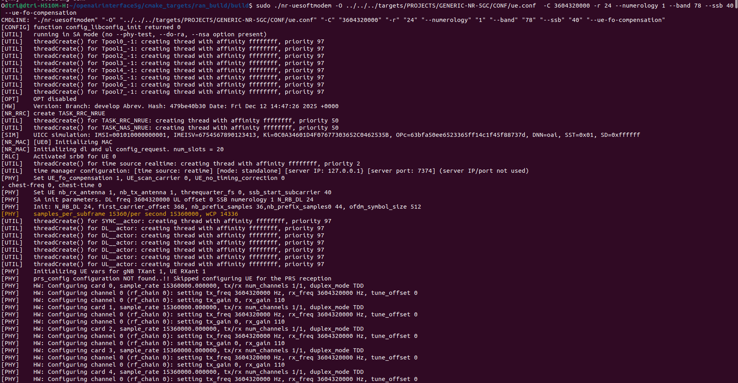
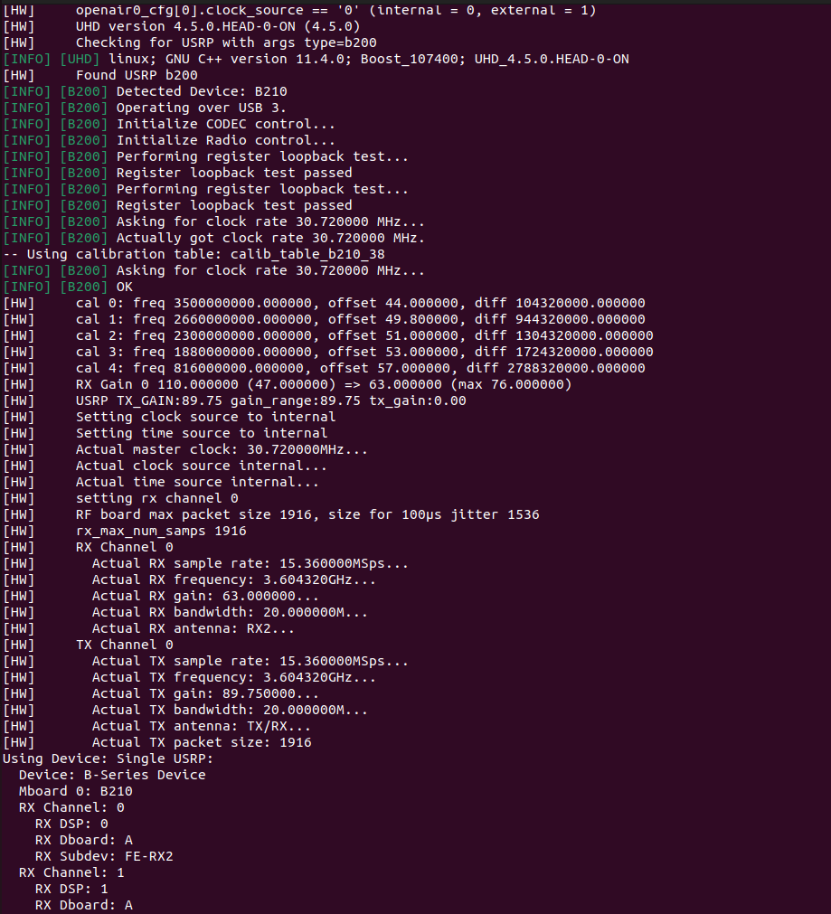
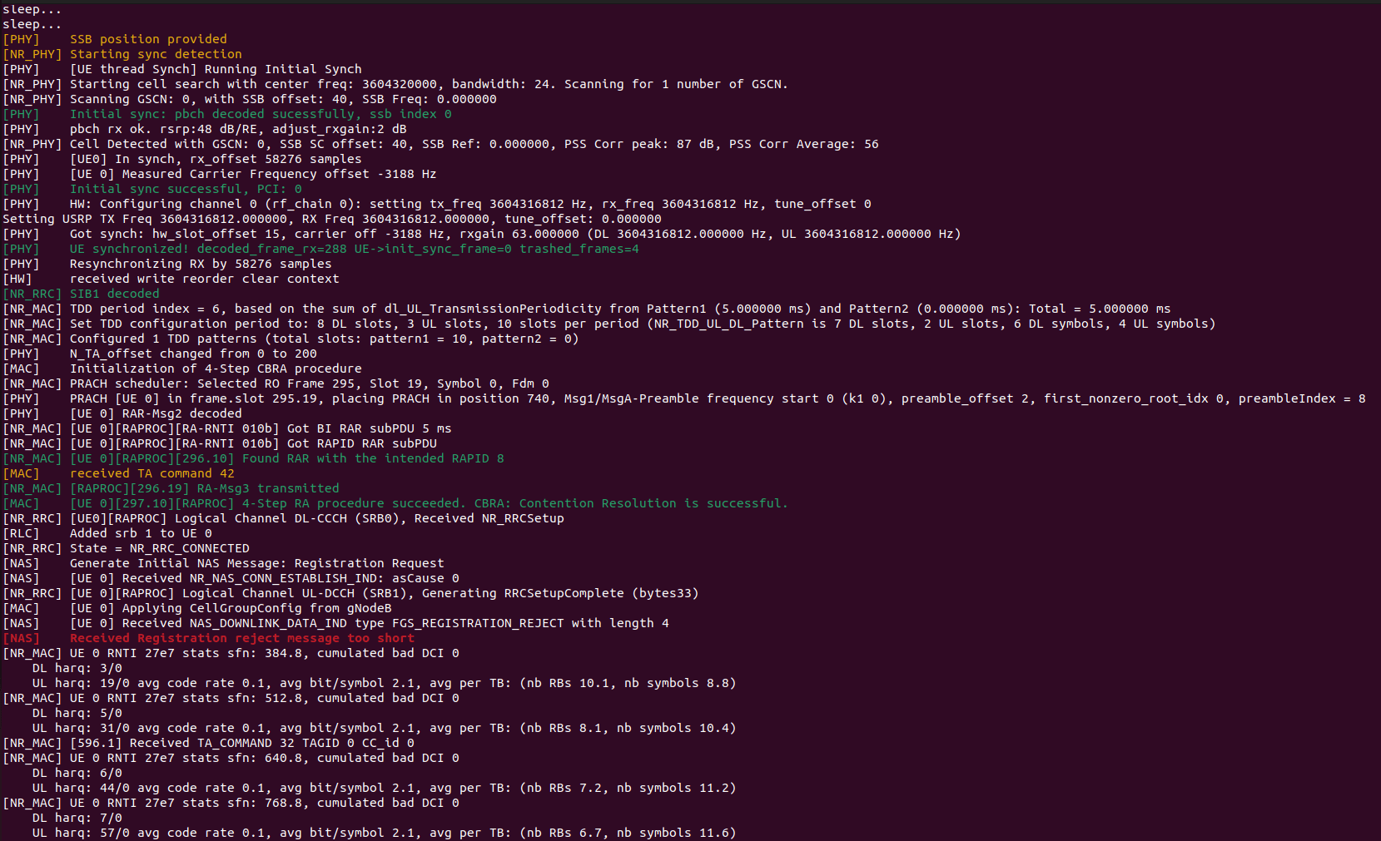
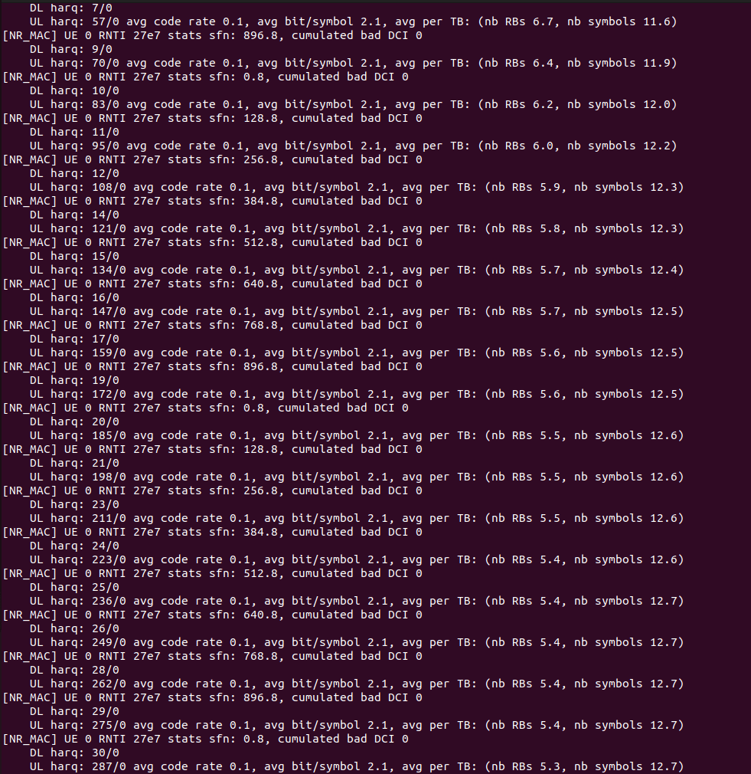
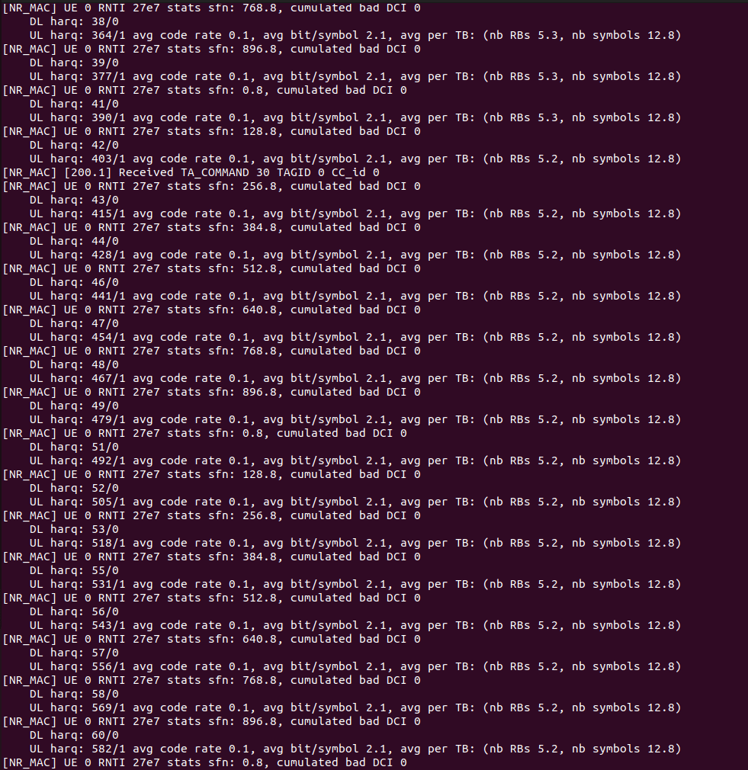
------------------------------------------------------------------------------------------------------------------------------------------------------------------------------------------------------------------------------------------------------------------------------------------The below is the Core Network logs-
